

Sukkur IBA University

Department of Computer Science
Applied Physics BS (CS)-II

Lab # 05: Capacitors in Series

Instructor: Engr: Asif Ali



 | Submission Profile
Name: | Submission date:
CMS I.D: | Receiving authority name and signature:
Comments:

________________________________________________________________________________

Instructor Signature

Objectives:

The objective of this Lab is to understand the series connection of the capacitors.

Lab Hardware and Software Required:
- NI Elvis-Kit
- Capacitors
- Connecting Wires
- PC
- MultiSim
- Connecting Probes

Background Theory:
A capacitor is a two-terminal electrical device that can store energy in the form of an electric charge. It consists of two electrical conductors that are separated by a distance. The space between the conductors may be filled by vacuum or with an insulating material known as a dielectric. The ability of the capacitor to store charges is known as capacitance. Capacitors store energy by holding apart pairs of opposite charges. The simplest design for a capacitor is a parallel plate, which consists of two metal plates with a gap between them.

How Does a Capacitor work?
For demonstration, let us consider the most basic structure of a capacitor – the parallel plate capacitor. It consists of two parallel plates separated by a dielectric. When we connect a DC voltage source across the capacitor, one plate is connected to the positive end (plate I) and the other to the negative end (plate II). When the potential of the battery is applied across the capacitor, plate I become positive with respect to plate II. The current tries to flow through the capacitor at the steady-state condition from its positive plate to its negative plate. But it cannot flow due to the separation of the plates with an insulating material. As shown in Figure1
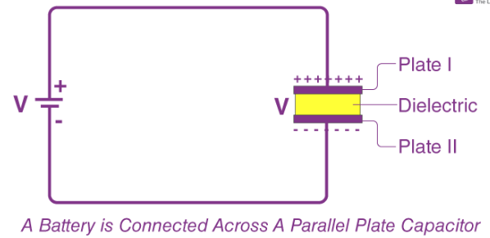
Figure 1

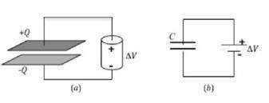
A capacitor is a set of two metal conductors separated by a small distance. Usually some type of dielectric (non-conducting) material2 is placed between the two conductors. An example is the parallel plate capacitor shown in Fig. 2. When connected to a voltage source, such as a battery, the two conducting plates become charged. When the battery is not connected, free electrons inside the top capacitor plate will move toward the positive terminal of the battery. This continues until the top capacitor plate is at the same potential as the positive terminal of the battery. A net positive charge, +Q, will then be on the top capacitor plate. At the same time, free electrons inside the wire connecting the negative terminal to the bottom capacitor plate will move toward the bottom capacitor plate. This continues until the bottom capacitor plate is at the same potential as the battery's negative terminal. A net negative charge, {Q, will be present on the bottom capacitor plate.

Fig. 2(a) shows a parallel-plate capacitor connected to a battery and Fig. 2(b) is the schematic diagram of the same setup. Note that the symbols for a capacitor and a battery are similar but not the same. Be careful not to confuse them.

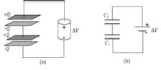
Note that there are equal and opposite charges (+Q and {-Q) on the two plates of the charged capacitor. For convenience, we simply refer to the magnitude of the charge and say that the capacitor has a charge Q on it. Also note that since the top capacitor plate is at the same potential as the positive battery terminal and the bottom plate is at the same potential as the negative battery terminal, the potential difference between the capacitor's two plates is the same as the potential difference across the terminals of the battery. The amount of charge deposited on a capacitor is directly proportional to the potential difference placed across its plates. This can be written as

Q = C∆V

Where the proportionality constant C is known as the capacitance3 of the capacitor and is measured in units of Farads4 (F). The capacitance depends on the particular geometry of the capacitor as well as the type of dielectric material used.

If you were to remove the battery from a charged capacitor, the charges would stay on the plates, and a potential difference would remain between the two plates of the capacitor. Therefore, we say that the capacitor stores" electrical energy. The amount of energy stored in a charged capacitor can be calculated using the formula

E= ½ C (∆V) ²

Capacitors Connected in Series
Frequently we want to combine multiple capacitors into one circuit. One way to combine capacitors is to connect them in series7 as shown in Fig. When connected to a battery, the bottom plate of the first capacitor C1 will store a charge {Q and the top plate of the second capacitor C2 will store a charge +Q. We see then that the total charge placed on the overall series arrangement by the battery is Q. Notice that the top plate of C1 and the bottom plate of C2 are connected by a conducting wire, forming a single H-shaped conductor.

This conductor is not connected to the battery, so the battery cannot directly provide charge to it. Instead, the negative charge {Q on the bottom plate of C1 and the positive charge +Q on the top plate of C2 will cause free electrons in the H-shaped conductor to move to the top. The result is an induced net charge of +Q on the top plate of C1 and an induced net charge of {Q on the bottom plate of C2. Therefore, both capacitors will have the same charge Q, which is the same as the total charge on the entire arrangement.

The bottom plate of C1 is at the same potential as the negative terminal of the battery, and the top plate of C2 is at the same potential as the positive terminal. The H-shaped conductor will have a potential somewhere in between these two values. So, moving from the top plate to the bottom plate of C2, the potential will drop by ∆V2: Then, moving from the top plate to the bottom plate of C1, the potential will drop by ∆V1: The potential difference ∆V across the entire series arrangement is equal to the sum of the potential differences across each individual capacitor.

We can use Eq. (1) to write the potential difference across the individual capacitors and the parallel arrangement as
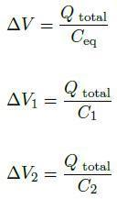

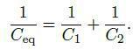
Substituting these expressions into Eq. (10), using Eq. (9), and cancelling the common factor, Q total; gives

The energy stored in the total series arrangement can be calculated using Eq. (4).

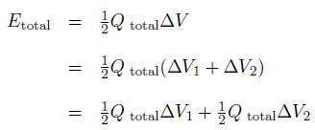

Note that this is the sum of the energies stored in each individual capacitor.
Listed below are the equations governing voltage distribution, charge distribution, equivalent capacitance, and energy storage for the two types of arrangements.

Procedure: Capacitance in Series
- Record the measured capacitances in data table 1.
- Connect two capacitors in series
- Measure the total capacitance of the combination and write in data table 1.
- Leave the series arrangement intact and discharge the capacitors one at a time.
- Connect with dc source.
- Measure voltage across each capacitor and record in data table 1.
- Measure the voltage across the combination and record it in data table 1.
- Using the measured value of capacitances and voltages, find the charge stored on each capacitor. Record in data table 1.
- Use measured value for total voltage and capacitance. Calculate charge in the series arrangement. Record in data table 1.
- Using measured values of capacitances, find energy stored in each capacitor and the combination and record in data table 1.
- Calculate the theoretical capacitance of the series combination and record this on worksheet.
- Calculate percent difference and record it in data table 1.
- Calculate theoretical voltage and record on worksheet.
- Calculate percent difference between theoretical and measured value and record in work sheet.

Exercise

Task1: Fill the following table

Table: 1 Capacitors in Series:

Calculate the theoretical equivalent capacitance for the two capacitors in series.
 | C1 (Larger Capacitance) | C2 (Smaller Capacitance) | Total Capacitance
C_{Cal (}(µF)
Cmeas (µF)
ΔV (v)
Qcalc (µC)
Ecalc (µJ)

